SELECTMEN’S MEETING AGENDA
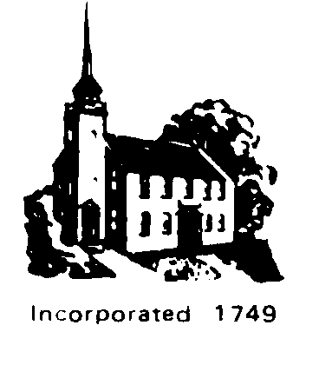
Monday, April 25, 2011 7:00 p.m.
Pledge to the Flag

Public Announcements
- Saturday, April 30th, Turn in your unused or expired medication for safe disposal at the Hampstead Fire Station between 10:00 a.m. and 2:00 p.m.
- Saturday, May 14th Kent Farm Facility is open from 8:00 a.m. to 4:00 p.m. A sticker is required and may per purchased from the Town Clerk/Tax Collector.
- Saturday May 14th is Household Hazardous Waste Day. It will be held in Plaistow from 9-noon.
- Saturday, May 21st Kent Farm Facility is open from 8:00 a.m. to 4:00 p.m. for brush and leaves disposal only.
- Waste Oil, fluorescent light bulbs, car batteries and thermostats are collected at the Town Garage on the first and third Saturdays of the month 8 am to 1 pm. Books may be dropped off at anytime.

Visitor Comments

Department Heads
- Additional paving at Town Office Building – Jon Worthen

New Business
- Awarding of bids, possible reconsideration

Old Business
- Liaisons Reports

Administrative Assistant’s Report

Action Items

Re- Appointments/Appointments
- Call for candidates :
  - Ordway Park, full members and alternates
  - Cable Committee volunteers
  - Recycling and Waste Disposal Committee
  - Capital Improvements
  - Rockingham Regional Planning Commission/Technical Advisory Committee
  - Rockingham Regional Planning Commissioner

Correspondence

Visitor Comments

Future Agenda Items
- Energy Committee
- Hampstead Senior Committee
- Town Administrator

Adjournment
Non-public pursuant to RSA 91A:3 II e (litigation)

The order of items on the agenda will be taken at the discretion of the Chairman.
Any person with a disability who wishes to attend this meeting and needs to be provided a reasonable accommodation in order to participate should call the Hampstead Selectmen's Office at 329-4100 at least twenty-four hours in advance so that arrangements can be made.

